How to add Skin Type Solutions to your website for maximum traffic
Step 1: Header Links
Add a new Dropdown to your website called “Skincare”. Add the following links
>“Shop Skincare” or “Shop Now”
URL: https://skintypesolutions.com/collections/shop-skincare-products?code=OWNAESTHETICS
>>Add a secondary link for “Take the Quiz” or “Baumann Skin Type Quiz”
URL: https://skintypesolutions.com/pages/skin-type-quiz?code=OWNAESTHETICS
Example

Step 2: Home Page Introduction
Add a section to your Home page that introduces the new system.
Personalized Skin Care by Skin Type Solutions
The science-based skin care system develops a personalized skin care routine based on your unique Baumann Skin Type®. Get your personalized skin care routine recommendation by taking the STS Skin Type Quiz. Or Shop now from a selection of the best dermatologist recommended skin care brands.
EXAMPLE:
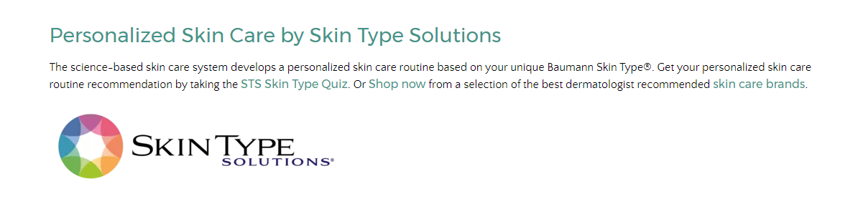
Step 3: About STS Page
Create a new Page on your website
TITLE: ABOUT SKIN TYPE SOLUTIONS
{{STS LOGO HERE}}
The science-based skin care system develops a personalized skin care routine based on your unique Baumann Skin Type®. Get your personalized skincare regimen recommendation by taking the STS Skin Type Quiz. Or Shop Now from a selection of the best dermatologist recommended skincare brands.
Why should I use Skin Type Solutions?
Get the best treatment possible with our {{PRACTICE NAME HERE}} fine-tuned product lines. After determining your skin type, you will have access to the most suitable moisturizers, eye creams, sunscreens, masks, toners, supplements, serums and more. Your skin will be nourished and protected all year round. Skin Type Solutions will provide all the products you need to keep your skin happy, healthy, and beautiful.
With Skin Type Solutions, you’re getting more than just the right skin care products from high-quality, exclusive brands. Thanks to our extensive resources, you will also receive in-depth explanations about your skin type and why it acts the way it does, expert dietary and lifestyle advice that leads to beautiful skin, exciting updates on the latest cosmetic procedures and skin treatments, and year-round skin care advice to ensure you treat your skin correctly in all seasons and weather.

Why is the Skin Type Quiz so important?
Before you start your new Skin Type Solutions skin care routine, you need to determine your skin type. Did you know that 80% of people don’t know their skin type? Chances are you’ve been treating your skin improperly. Thanks to the revolutionary skin typing system created by Dr. Leslie Baumann, you can discover your true skin type, whether that’s Type 1: Dry, Sensitive, Pigmented and Tight, or Type 12: Oily, Resistant, Non-Pigmented and Wrinkle Prone. For each of the 16 unique skin types
How was the Skin Type Quiz Validated?
EXAMPLE:
